
SYSTEM TEST PLAN – YD12 Release

Author: Mahesh Ishwar
Cyrus Test Team
Date: 24-Oct-2017
TUI UK & Ireland IT

Document Aim:
To define the System Test Plan for Multi-Currency and Bed Bank Phase 1

Document Control

Version History
Version | Date | Author | Description
0.1 | 15-OCT-17 | Mahesh Ishwar | Draft version
0.2 | 24OCT-17 | Mahesh Ishwar | Updated function Tests

Distribution List
Name | Title | Purpose | Date
Adam Rayner | General Manager - Yield Analytics | Approval
Richard Kerr | Delivery Manager | Approval
Farhan Ahmed | Yield Test Manager | Approval
Umesh N | Delivery Lead | Information
Mark Bostock | Consultant – Commercial Analytics | Review
Bijeesh Chathoth | Solution Designer | Review

Table of Contents
1. Introduction 4
1.1. Background 4
1.2. References 4
2. System Integration Test (SIT) Approach 5
2.1. Cyrus Testing Plan on a Page 5
2.2. Overview 5
2.3. In Scope 6
2.4. Out of Scope 7
2.5. Acceptance Criteria 7
2.6. Test Automation 8
2.7. Phase Containment 8
2.7.1. Entry Criteria 8
2.7.2. Exit Criteria 8
2.8. Test Environment 8
2.9. Test Data 9
3. Test Type 9
3.1. Smoke Testing 9
3.2. Functional Testing 9
3.3. Regression Testing 9
3.4. E2E Testing 9
3.5. NFR Testing 10
4. Test Schedule 10
5. Risks, Assumptions and Dependencies 10
5.1. Risks 10
5.2. Assumptions & Dependencies 11
6. Communication plan 11
6.1. Progress Reports 11

Introduction
The purpose of this document is to define the approach and schedule for Cyrus System Integration Test (SIT) and part of Production Acceptance Test (PAT) pertaining to YD12 Iteration which is planned between 02-OCT-2017 to 03-Nov-2017 as per the Yield 2017 delivery plan.

Background

YD12 Sprint has been created under UK Projects in Rally containing German and UK requirements. This document details the Plan to test these requirements.

References

Reference | Document name and Location
User Stories | Rally-  https://rally1.rally
Design Document | Rally-  https://rally1.rallydev.c
Cyrus Test Strategy | Cyrus Test Strategyv1.0 (location to be updated)
Data Specs | 6.4.3

System Integration Test (SIT) Approach

Cyrus Testing Plan on a Page
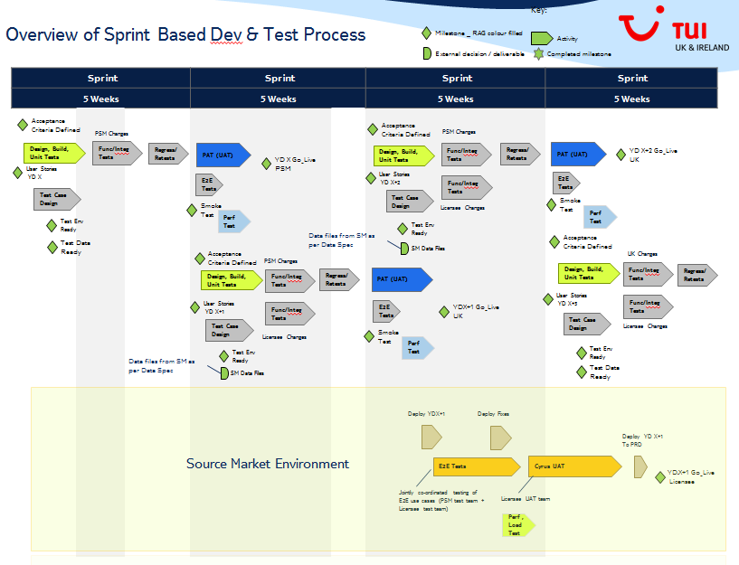

Overview
The SIT phase will involve testing of functionalities for YD12 backlog, which includes User Stories and Defect pulled in the “02-OCT-2017 to 03-nov-2017” sprint iteration in rally. This also includes verifying the data load and data integration aspects. The testing comprises of testing functionalities for Data Mart module, Server Module and Work Station module.
YD12 release comprise of UK and TUI-DE functionalities.
UK Functionality:
All UK functionalities will be tested in UK environment. Regression testing will also be done for all the changed modules/functions in YD12 release for UK source market. Performance of CYRUS processes with UK data will be tested in the UK PAT environment (after releasing YD12 to PAT) in the next sprint.

German Functionality:
TUI- DE functionalities will be tested in German environment (DCYT and CYUAT1). Performance and E2E functionality will be in German PAT environment in the Next Sprint.
Please note that separate Test Plan and sprint (under German Project in rally) exist for ETS testing with German data. So this document doesn’t cover this ETS testing in detail.

In Scope

Following are in the scope of functional and regression Testing:
Formatted ID | Feature | Name
US37461 | Feature F1457: General CRs | [Requirement user story] CRXXX: Changes to i3PF logic to correctly handle Child Adjustments
US44556 | Feature F1457: General CRs | US37461 CRXXX: Changes to i3PF logic to correctly handle Child Adjustments (Calculate3PFPrice function)
US44557 | Feature F1457: General CRs | US37461 CRXXX: Changes to i3PF logic to correctly handle Child Adjustments( Change to operators at U30)
US44558 | Feature F1457: General CRs | US37461 CRXXX: Changes to i3PF logic to correctly handle Child Adjustments (logic to consistently handle 3PF Max Discount )
US40232 | Feature F1660: Duration Control | [Requirement User Story] CRXXX DC Moves Transfer Process
US44416 | Feature F1660: Duration Control | US40232: CRXXX DC Moves Transfer Process – iSeats
US44417 | Feature F1660: Duration Control | US40232: CRXXX DC Moves Transfer Process - Manual moves
US41514 | Feature F1507: Architecture Review - PL/SQL Parallelisation | [Requirement User Story] Parallel Execution - EDC : apply to EDC build (PKG Only)
US44394 | Feature F1507: Architecture Review - PL/SQL Parallelisation | Parallel Execution - EDC : apply to EDC build (PKG Only) - Part 1 (Staging table population)
US44395 | Feature F1507: Architecture Review - PL/SQL Parallelisation | Parallel Execution - EDC : apply to EDC build (PKG Only) - part 2 (Main table population)
US42167 | Feature F1507: Architecture Review - PL/SQL Parallelisation | [Requirement User Story] Parallel Execution - FAO : apply to FAO build process
US44392 | Feature F1507: Architecture Review - PL/SQL Parallelisation | Parallel Execution - FAO : apply to FAO build process - MAD calculation
US44393 | Feature F1507: Architecture Review - PL/SQL Parallelisation | Parallel Execution - FAO : apply to FAO build process - Cache table population
US42659 | Feature F1338: Service Delivery Recommendations | [Requirement User Story] SD Supportability Improvements: phase 1 requirements
US44443 | Feature F1338: Service Delivery Recommendations | SD Supportability Improvements: phase 1 requirements - Part 1
US44444 | Feature F1338: Service Delivery Recommendations | SD Supportability Improvements: phase 1 requirements - Part 2
DE71019 |  | FTS Accom Msr Integration overrunning
DE69177 |  | [DE UAT] TUI DE Values being Picked up for H and Z packages when Shouldn't be
US43484 | Feature F1399: Bed banks phase 2a | US42010: BB Reporting - accom inventories with 999 cax
DE70106 |  | CYPRD SEV3 RDY 532953; DE70106; Intraday Flight Measure Change Not Triggering LE 11-SEP-2017
US44342 | Feature F1047: TUI DE - PARALLEL FLIGHT SELECTION | TUI DE: Functional testing - Variable Flying -Data mart - Part2 - To test matching parallel flights for Cyrus packages and GLF in PP table
DE68628 |  | CYPRD Sev3 Rdy XXXXX; DE68628; Emails not being sent when there are LE Server failures 21-Jul-17
US44084 | Feature F1400: One Way Seats | OWS Uncapped FTS Overspill equation change
US43486 | Feature F1399: Bed banks phase 2a | US42010: BB Reporting - Catalogue promotion code setting
US43222 | Feature F1616: Multiple gateways | Accommodating Multiple Gateways: Create i3PF packages for accommodations with multiple gateways [Development]
US43478 | Feature F1616: Multiple gateways | Accommodating Multiple Gateways: Create 3PF packages for accommodations with multiple gateways [Development]
US44427 | Feature F1616: Multiple gateways | Accommodating Multiple Gateways: System Testing of US43322 and US43478
US43480 | Feature F1616: Multiple gateways | Accommodating Multiple Gateways: System Testing of US43320 and US43321
US43674 |  | TO test MI defect DE63945 impact on Cyrus
US44167 | Feature F1047: TUI DE - PARALLEL FLIGHT SELECTION | US41024 : TUI DE: Functional testing - Variable Flying -Data mart - testing of costs and margins data
US44425 | Feature F1398: Flight Only Competitor Pricing | FOCP Phase1 - US39856 - Price Up Logic - DM Changes for LE
US39503 | Feature F1699: TUI DE - Accom Contract | CRXXX TUI DE Accom Contract Commitment Provided Via Source Data
US41370 | Feature F1398: Flight Only Competitor Pricing | FOCP Phase1 - US39856 - Price Up Logic (LE)
US41914 | Feature F1048: TUI DE - Promotional Prices in Cyrus | TUI DE : Functional Testing : Promotional Pricing
US44194 | Feature F1047: TUI DE - PARALLEL FLIGHT SELECTION | US41024- TUI DE : Functional Testing - Variable Flying (Logic Engine testing) – Part 2
US44199 | Feature F1398: Flight Only Competitor Pricing | FOCP Phase1 - US39856 - Flight Only Competitor Mapping process: Similarity Scoring, Price Normalisation & Combined Mapping
US44609 | Feature F1389: Technical - Deployment & Environment setup | TUI DE - Configuration/Setup of Cyrus in PAT/PROD

Out of Scope
- TUI-DE ETS testing is not part of YD12 as this is tracked separately (German sprints).
- The performance testing related to test load and stress with multiple users are not in the SIT scope.

Acceptance Criteria
- Acceptance criteria for each individual story in scope of YD12 should be met
- Cyrus DE functionalities should be switched off on live in UK
- Cyrus UK functionalities should be switched off on live in DE

Test Automation
The following are in scope for automated tests:

- Data Integrity: 80% of the Data integrity Tests have been automated- this will be used for Testing the German Data
- Flight/Accom/Package Integration: Flight/Accom/package integration
- Accom Measure: Accom measure will also be tested
- LE : Accom and Package adjustments will be tested

Phase Containment

Entry Criteria
The following criteria must be met before integration testing can commence:
- Unit testing has been successfully completed by Dev team.
- Relevant test cases have been defined in Rally and have been peer reviewed/approved.
- Test plan has been reviewed by stakeholders and approved.
- Build for YD12 release has been given with the Release notes
- Build for current release has been deployed into SIT Environment i.e. CYUAT1 and CYUAT2.
- Test Environment for SIT is ready and available for use
- Latest Test data for SIT is ready and available for use.
- TUI DE new extract to be verified in ETS testing, then it will be used for SIT functional testing

Exit Criteria
Testing will be deemed as complete when the following criteria have been met:
- All user stories in the Rally updated with state as “Complete”.
- All integration tests have been successfully completed and the actual results are documented in Rally.
- All P1 & P2 defects have been fixed and closed in Rally
- Integration test results have been reviewed/ approved.
- Show and Tell for YD12 user stories in scope has been completed.
- All Open P3 & P4 defects have been reprioritised after discussion with PO and move to subsequent sprint i.e. YD13.
- Stories that have passed SIT and related defects closed are updated as “Complete” in Rally.
- Stories not marked as “Complete” have been scheduled for an upcoming Sprint after discussions with relevant stakeholders.
- SIT sign off has been received.

Test Environment
For YD12 release we are using two test environments as mentioned below:
- CYUAT2 – This test environment will be used to do the functional test of UK related functionalities and also regression testing to ensure UK functionalities work fine with the TUI-De code
- DCYT/CYUAT1 – This test environment will be used to do the functional testing of the TUI-DE (German) functionalities.
- CYPAT8 -> US43674 /DE63945 and US40232/ US44416/ US44417 need E2E connection so these will be Tested in the CYPAT8 environment

Test Data Requirements
- German extracts will be used for Testing TUI-DE functionality in DCYT/CYUAT1
- Test Data in the CYUAT2 test environment will be used to test the UK functionalities
- Some accoms should be setup up with 2 gateways and some with more than 2 gateways in the PAT8 environment to test the Multiple gateway solution

Test Type

Smoke Testing
Smoke testing will be done after deploying the YD12 versions into the test environment. A set to test cases will be executed to verify if build deployment is successful and No blocker exists for functional testing to start.

Functional Testing
The TUI-DE related User Stories will be tested in DCYT/CYUAT1 test environment. All the UK related User Stories will be tested in CYUAT2. Any issues found during testing will be logged as a defect in Rally.
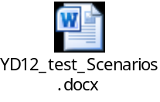

Regression Testing
In YD12 release, regression testing will be carried out for all changed modules/functions in the UK environment with UK data (please see US’s which will be used to identify the functions to be regression tested in section 2.3 of this document). Tests in the current automation framework (flight/accom/package integration, Accom Measure, Accom and Package LE rules) will be used in this Test cycle. Tests which are not in the current Automation framework will be run as Manual Tests.
This includes regression for Logic Engine (ETS flow) and all Datamart & WS functionalities changed in this version of Yield delivery (YD12).

PAT Testing
SIT Team will Monitor the all the Cyrus processes (including FULL/Incremental/Intraday processes) in the PAT for four days and run the tests for key functionality implemented in the YD release.

E2E Testing
End To End testing will be done on CYPAT8/CYPAT on the subsequent sprint for the functionalities which require end-to-end test case execution

NFR Testing
Performance testing related to response time by processing the packages will be done on PAT in the subsequent Sprint. The scope of Performance Test will be as below:
- Processing the packages
- Data loading etc., and capturing the time.

Test Schedule
The SIT schedule will follow the Sprint based delivery schedule for the release. The Sprint will have following task for test team
YD12 start and end dates:
Task | Start Date | End Date | Comment
Test analysis, design, test case preparation, test execution, defect logging and retesting | 02-OCT-2017 | 03-NOV-17

PAT8 is required from 24-OCT till 03 NOV (for Testing DC transfer changes, multiple gateways and MI fix)

Risks, Assumptions and Dependencies

Risks
S No | Risk | Impact | Mitigation
1 | TUI-DE data Issues | Issues in TUI-DE extracts may affect/block the Functional Testing | High Priority issues to be fixed quickly to avoid delays to the Testing cycle
2 | Number of patches for data issues | If more number of patches delivered, number of test cycles will increase. | Increase in Test effort for patches should be discussed and agreed
3 | No accoms have more than 2 gateways in PAT8 and PAT | Multiple gateways logic cannot be tested with more than 2 gateways for accoms | More than 2 gateways should be set for at least one Accom in PAT8
4 | MI code for US43674 /DE63945 has not been released yet for CYRUS Testing | Not possible to complete the testing if it is not released to CYRUS team before 27OCT | Discuss and agree on moving this to YD13
5 | Cyrus Defect DE71512 to be fixed | Without this fix US43674 /DE63945 can’t be tested | Defect to be prioritised and included in YD12 if US43674 /DE63945 required in YD12
6 | PAT8 purge and repointing to ST3 activities planned for W/c 16-OCT | PAT8 environment is required for US43674 /DE63945 (MI fix) and US40232/ US44416/ US44417 (DC transfer testing). It will affect the testing activities if environment is not available on w/c 23OCT | Make sure that PAT8 activities completed by 23OCT/24OCT.  In case of delays, discuss and agree on moving this testing to PAT environment

Assumptions & Dependencies
- Trial margin has not been successfully loaded into German environment yet. Variable flying logic to be tested with dummy margin/cost.
- Initial Performance testing will be done in SIT environment (non-exadata) for Parallel execution changes (FAO and EDC). Performance should be tested in the PAT environment (exadata) also after deploying YD12.
- SIT environment doesn’t have connection to @com So US43674 /DE63945 should be tested in PAT8 environment
- US40232/ US44416/ US44417 (DC transfer) also to be tested in PAT8.

Communication plan

Progress Reports
Following are the reports created to track the YD12 release progress
- Testing Dashboard highlighting progress and metrics
- Defect report based on status
- SIT sign-off document

